PHP Login Script with Session Tutorial – Step by Step Guide!
Last Update: •Date Posted: •by Mike Dalisay➜Get FREE Updates Here
Previously, we learned how to create, read, update and delete database records on our PHP OOP CRUD tutorial. Today, we will put some of that knowledge to work by building a simple PHP login script with session.
This post has the following contents:
1.0 Overview
2.0 Program output
3.0 File structure
4.0 Prepare the database
4.1 Create a database
4.2 Run SQL for users table
4.3 Run SQL for user accounts
4.4 Create database connection file
4.5 Create user object file
6.5 Output
5.0 Prepare basic settings
5.1 Create config file
5.2 Create login checker file
5.3 Create .htaccess file
5.4 Output
6.0 Create the template files
6.1 Create navigation bar
6.2 Show logout button
6.3 Show login and register buttons
6.4 Create page header
6.5 Create page footer
6.6 Customer section custom CSS
6.7 Output
7.0 Create login form
7.1 Include basic settings
7.2 Login form HTML
7.3 Login form output
7.4 Add alert message
7.5 Alert message output
7.6 If user submitted the form
7.7 Check if email exists
7.8 Add emailExists() method
7.9 Validate login credentials
7.10 Customer’s index page
7.11 Logout file
7.12 Output
8.0 Create registration form
8.1 Create register page
8.2 Create Utils class
8.3 Registration form HTML
8.4 If registration form was submitted
8.5 Create new user
8.6 User object create() method
8.7 Add showError() method
8.8 Output
9.0 Admin section
9.1 Create admin index page
9.2 Create navigation bar
9.3 Create page header
9.4 Create page footer
9.5 Admin section custom CSS
9.6 Create login checker file
9.7 Output
10.0 Show registered users
10.1 Create "read users" file
10.2 Add readAll() method in user object
10.3 Create "read users" template file
10.4 Add countAll() method in user object
10.5 Paginate list of users
10.6 Output
11.0 How to validate email address?
11.1 Change account status
11.2 Add access code field
11.3 Add getToken() method
11.4 Change create() method
11.5 Add access_code property
11.6 Send verification email
11.7 Add sendEmailViaPhpMail() method
11.8 Output
11.9 Create verification file
11.10 Add accessCodeExists() method
11.11 Add updateStatusByAccessCode() method
11.12 Output
12.0 PHP forgot password form
12.1 Add forgot password link
12.2 Login page new output
12.3 Create “forgot password” page
12.4 Forgot password page output
12.5 Add post code
12.6 Add updateAccessCode() method
12.7 Output
13.0 PHP reset password form
13.1 Create “reset password” page
13.2 Check access code
13.3 Add accessCodeExists() method
13.4 Add “reset password” form
13.5 Add post code
13.6 Add updatePassword() method
13.7 Output
14.0 How To Run The Source Code?
15.0 Download LEVEL 1 Source Code
16.0 Download PHP Login System
17.0 What’s Next?
18.0 Related Tutorials
19.0 Notes
Before we start, we want to let you know that your feedback is important to us!
If you have a positive feedback about our work, please let us know. If there's a section in this tutorial that is confusing or hard to understand, we consider it as a problem. Please let us know as well.
Write your positive feedback or detailed description of the problem in the comments section below. Before you write a comment, please read this guide and our code of conduct. Thank you!

1.0 Overview
Login? Logout? Sign Up or Register? We see this functionality in almost every website we use today. Facebook, GMail and Twitter are just some examples.
If you want to become a web programmer, this is one of the most basic skills that you need to learn. If you haven't, today is a great day for you. We have some good news.
In this tutorial, we will learn how to build a simple PHP login script. This will help you create the web app of your dreams. Just like how we build ours.
We will cover how to create a login form, registration form, customer section, admin section, list of registered users, logout and more. You will learn useful web programming techniques as well.

2.0 Program Output

2.1 LEVEL 1 Source Code Output

- #1 Login Page

2.2 PHP Login System Source Code Output

- #7 Admin Section

3.0 File structure

At the end of this tutorial, we will have the following folders and files. You will learn the purpose of each of these files and folders as we go along the tutorial.
├─ admin/
├────── index.php
├────── layout_foot.php
├────── layout_head.php
├────── login_checker.php
├────── navigation.php
├────── paging.php
├────── read_users_template.php
├────── read_users.php
├─── config/
├────── core.php
├────── database.php
├─── images/
├────── login_icon.png
├─ libs/
├────── css/
├───────── admin.css
├───────── customer.css
├────── php/
├───────── utils.php
├─ objects/
├────── user.php
├─ .htaccess
├─ index.php
├─ layout_foot.php
├─ layout_head.php
├─ login_checker.php
├─ login.php
├─ logout.php
├─ navigation.php
├─ register.php

4.0 Prepare the database

4.1 Create a database
Open a new browser tab and go to PhpMyadmin. The address is http://localhost/phpmyadmin.
Create a database. Database name is: php_login_system
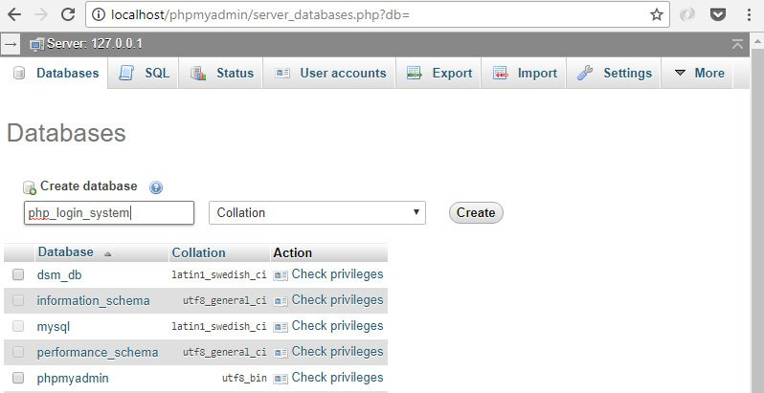

4.2 Run SQL for users table
In PhpMyAdmin, click the database name. Go to SQL tab. Create the "users" table by running the following SQL statement.
CREATE TABLE `users` (
`id` int(11) NOT NULL AUTO_INCREMENT,
`firstname` varchar(32) NOT NULL,
`lastname` varchar(32) NOT NULL,
`email` varchar(64) NOT NULL,
`contact_number` varchar(64) NOT NULL,
`address` text NOT NULL,
`password` varchar(512) NOT NULL,
`access_level` varchar(16) NOT NULL,
`access_code` text NOT NULL,
`status` int(11) NOT NULL COMMENT '0=pending,1=confirmed',
`created` datetime NOT NULL,
`modified` timestamp NOT NULL DEFAULT CURRENT_TIMESTAMP ON UPDATE CURRENT_TIMESTAMP,
PRIMARY KEY (id)
) ENGINE=InnoDB DEFAULT CHARSET=utf8 COMMENT='admin and customer users';

4.3 Run SQL for users accounts
Go to PhpMyAdmin's SQL tab again. Insert new records to users table by running the following SQL statement.
INSERT INTO `users` (`id`, `firstname`, `lastname`, `email`, `contact_number`, `address`, `password`, `access_level`, `access_code`, `status`, `created`, `modified`) VALUES
(1, 'Mike', 'Dalisay', 'mike@example.com', '0999999999', 'Blk. 24 A, Lot 6, Ph. 3, Peace Village', '$2y$10$AUBptrm9sQF696zr8Hv31On3x4wqnTihdCLocZmGLbiDvyLpyokL.', 'Admin', '', 1, '0000-00-00 00:00:00', '2016-06-13 18:17:47'),
(2, 'Lauro', 'Abogne', 'lauro@eacomm.com', '08888888', 'Pasig City', '$2y$10$it4i11kRKrB19FfpPRWsRO5qtgrgajL7NnxOq180MsIhCKhAmSdDa', 'Customer', '', 1, '0000-00-00 00:00:00', '2015-03-24 07:00:21'),
(4, 'Darwin', 'Dalisay', 'darwin@example.com', '9331868359', 'Blk 24 A Lot 6 Ph 3\r\nPeace Village, San Luis', '$2y$10$tLq9lTKDUt7EyTFhxL0QHuen/BgO9YQzFYTUyH50kJXLJ.ISO3HAO', 'Customer', 'ILXFBdMAbHVrJswNDnm231cziO8FZomn', 1, '2014-10-29 17:31:09', '2016-06-13 18:18:25'),
(7, 'Marisol Jane', 'Dalisay', 'mariz@gmail.com', '09998765432', 'Blk. 24 A, Lot 6, Ph. 3, Peace Village', 'mariz', 'Customer', '', 1, '2015-02-25 09:35:52', '2015-03-24 07:00:21'),
(9, 'Marykris', 'De Leon', 'marykrisdarell.deleon@gmail.com', '09194444444', 'Project 4, QC', '$2y$10$uUy7D5qmvaRYttLCx9wnU.WOD3/8URgOX7OBXHPpWyTDjU4ZteSEm', 'Customer', '', 1, '2015-02-27 14:28:46', '2015-03-24 06:51:03'),
(10, 'Merlin', 'Duckerberg', 'merlin@gmail.com', '09991112333', 'Project 2, Quezon City', '$2y$10$VHY58eALB1QyYsP71RHD1ewmVxZZp.wLuhejyQrufvdy041arx1Kq', 'Admin', '', 1, '2015-03-18 06:45:28', '2015-03-24 07:00:21'),
(14, 'Charlon', 'Ignacio', 'charlon@gmail.com', '09876543345', 'Tandang Sora, QC', '$2y$10$Fj6O1tPYI6UZRzJ9BNfFJuhURN9DnK5fQGHEsfol5LXRu.tCYYggu', 'Customer', '', 1, '2015-03-24 08:06:57', '2015-03-24 07:48:00'),
(15, 'Kobe Bro', 'Bryant', 'kobe@gmail.com', '09898787674', 'Los Angeles, California', '$2y$10$fmanyjJxNfJ8O3p9jjUixu6EOHkGZrThtcd..TeNz2g.XZyCIuVpm', 'Customer', '', 1, '2015-03-26 11:28:01', '2015-03-26 03:39:52'),
(20, 'Tim', 'Duncan', 'tim@example.com', '9999999', 'San Antonio, Texas, USA', '$2y$10$9OSKHLhiDdBkJTmd3VLnQeNPCtyH1IvZmcHrz4khBMHdxc8PLX5G6', 'Customer', '0X4JwsRmdif8UyyIHSOUjhZz9tva3Czj', 1, '2016-05-26 01:25:59', '2016-05-25 17:25:59'),
(21, 'Tony', 'Parker', 'tony@example.com', '8888888', 'Blk 24 A Lot 6 Ph 3\r\nPeace Village, San Luis', '$2y$10$lBJfvLyl/X5PieaztTYADOxOQeZJCqETayF.O9ld17z3hcKSJwZae', 'Customer', 'THM3xkZzXeza5ISoTyPKl6oLpVa88tYl', 1, '2016-05-26 01:29:01', '2016-06-13 17:46:33');

4.4 Create database connection file
This class is used for connecting to database.
I assume you are using XAMPP. Go to the root directory. In my case, it is the "C:\xampp\htdocs" directory.
We will create our project's folder. Create "php-login-script-level-1" folder. Open that folder.
Create "config" folder and open it. Create database.php file. Place the following code.
<?php
// used to get mysql database connection
class Database{

// specify your own database credentials
private $host = "localhost";
private $db_name = "php_login_system";
private $username = "root";
private $password = "";
public $conn;

// get the database connection
public function getConnection(){

$this->conn = null;

try{
$this->conn = new PDO("mysql:host=" . $this->host . ";dbname=" . $this->db_name, $this->username, $this->password);
}catch(PDOException $exception){
echo "Connection error: " . $exception->getMessage();
}

return $this->conn;
}
}
?>

4.4 Prepare user object
This class is used for "user" object operations such as creating a user, deleting a user and more. We will add several methods in this class as we go along this tutorial.
For now, we will just put the PHP class structure and necessary object properties.
Create "objects" folder. Create "user.php" file. Place the following code.
<?php
// 'user' object
class User{

// database connection and table name
private $conn;
private $table_name = "users";

// object properties
public $id;
public $firstname;
public $lastname;
public $email;
public $contact_number;
public $address;
public $password;
public $access_level;
public $access_code;
public $status;
public $created;
public $modified;

// constructor
public function __construct($db){
$this->conn = $db;
}
}

4.5 Output
Congratulations! We just made the set up for our login script's database. We do not have an output on a webpage yet. Continue the tutorial below to achieve more output.

5.0 Prepare basic settings

5.1 Create config file
Using a config file is great for your app. It is a central place where you can set common variables such as your apps home URL, pagination settings and more.
Open "config" folder. Create "core.php" file. Place the following code.
<?php
// show error reporting
error_reporting(E_ALL);

// start php session
session_start();

// set your default time-zone
date_default_timezone_set('Asia/Manila');

// home page url
$home_url="http://localhost/php-login-script-level-1/";

// page given in URL parameter, default page is one
$page = isset($_GET['page']) ? $_GET['page'] : 1;

// set number of records per page
$records_per_page = 5;

// calculate for the query LIMIT clause
$from_record_num = ($records_per_page * $page) - $records_per_page;
?>

5.2 Create login checker file
A login checker file is used by our web app to identify if a user is logged in or not.
If a user is not logged in and he tries to access a page where a login is required, that user will be redirected to login page.
Also, if a logged in user tries to access a login page, he will be redirected to the dashboard because he is already logged in.
Back to root directory, create "login_checker.php" file. Place the following code.
<?php
// login checker for 'customer' access level

// if access level was not 'Admin', redirect him to login page
if(isset($_SESSION['access_level']) && $_SESSION['access_level']=="Admin"){
header("Location: {$home_url}admin/index.php?action=logged_in_as_admin");
}

// if $require_login was set and value is 'true'
else if(isset($require_login) && $require_login==true){
// if user not yet logged in, redirect to login page
if(!isset($_SESSION['access_level'])){
header("Location: {$home_url}login.php?action=please_login");
}
}

// if it was the 'login' or 'register' or 'sign up' page but the customer was already logged in
else if(isset($page_title) && ($page_title=="Login" || $page_title=="Sign Up")){
// if user not yet logged in, redirect to login page
if(isset($_SESSION['access_level']) && $_SESSION['access_level']=="Customer"){
header("Location: {$home_url}index.php?action=already_logged_in");
}
}

else{
// no problem, stay on current page
}
?>

5.3 Create .htaccess file
The .htaccess file use very useful to make URLs pretty and easy to remember.
For example, page page on this URL "http://localhost/login.php" can be accessed using this URL "http://localhost/login".
Create ".htaccess" file. Place the following code.
#Fix Rewrite
Options -Multiviews

# Mod Rewrite
Options +FollowSymLinks
RewriteEngine On
RewriteBase /php-login-script-level-1/

RewriteCond %{REQUEST_FILENAME} !-f
RewriteCond %{REQUEST_FILENAME} !-d

# used for php pages such as "yoursite.com/login.php" will become "yoursite.com/login/"
RewriteRule ^([a-z_]+)\/?$ $1.php [NC]

To make .htaccess file work, make sure mod_rewrite Apache module was enabled in your server. Learn more here and here.

5.4 Output
Congratulations! We just made the basic set up of our login script. We do not have an output on a webpage yet. Continue the tutorial below to achieve more output.

6.0 Create the template files
Template files are very useful because it saves us a lot of time. How? When you use template files, you won't have to repeat the common codes on each web page you are working on.
The examples of those common codes are the HTML tags on the 'head' and 'foot' of the web page. We will learn more about this concept as we go along this tutorial.

6.1 Create navigation bar
The navigation is where the user can click the home page link, logout button and more.
Create "navigation.php" file. Place the following code.
<!-- navbar -->
<div class="navbar navbar-default navbar-static-top" role="navigation">
<div class="container-fluid">

<div class="navbar-header">
<!-- to enable navigation dropdown when viewed in mobile device -->
<button type="button" class="navbar-toggle" data-toggle="collapse" data-target=".navbar-collapse">
<span class="sr-only">Toggle navigation</span>
<span class="icon-bar"></span>
<span class="icon-bar"></span>
<span class="icon-bar"></span>
</button>

<!-- Change "Your Site" to your site name -->
<a class="navbar-brand" href="<?php echo $home_url; ?>">Your Site</a>
</div>

<div class="navbar-collapse collapse">
<ul class="nav navbar-nav">
<!-- link to the "Cart" page, highlight if current page is cart.php -->
<li <?php echo $page_title=="Index" ? "class='active'" : ""; ?>>
<a href="<?php echo $home_url; ?>">Home</a>
</li>
</ul>

<?php
// login and logout options will be here
?>

</div><!--/.nav-collapse -->

</div>
</div>
<!-- /navbar -->

6.2 Show logout button
If the user was logged-in, the system will show them a logout button in the navigation bar.
Replace "// login and logout options will be here " of the previous section with the following code.
// check if users / customer was logged in
// if user was logged in, show "Edit Profile", "Orders" and "Logout" options
if(isset($_SESSION['logged_in']) && $_SESSION['logged_in']==true && $_SESSION['access_level']=='Customer'){
?>
<ul class="nav navbar-nav navbar-right">
<li <?php echo $page_title=="Edit Profile" ? "class='active'" : ""; ?>>
<a href="#" class="dropdown-toggle" data-toggle="dropdown" role="button" aria-expanded="false">
<span class="glyphicon glyphicon-user" aria-hidden="true"></span>
&nbsp;&nbsp;<?php echo $_SESSION['firstname']; ?>
&nbsp;&nbsp;<span class="caret"></span>
</a>
<ul class="dropdown-menu" role="menu">
<li><a href="<?php echo $home_url; ?>logout.php">Logout</a></li>
</ul>
</li>
</ul>
<?php
}

// show login and register options here

6.3 Show login and register buttons
If the user is not yet logged-in, the system will show them the login and register buttons in the navigation bar.
Replace "// show login and register options here " of the previous section with the following code.
// if user was not logged in, show the "login" and "register" options
else{
?>
<ul class="nav navbar-nav navbar-right">
<li <?php echo $page_title=="Login" ? "class='active'" : ""; ?>>
<a href="<?php echo $home_url; ?>login">
<span class="glyphicon glyphicon-log-in"></span> Log In
</a>
</li>

<li <?php echo $page_title=="Register" ? "class='active'" : ""; ?>>
<a href="<?php echo $home_url; ?>register">
<span class="glyphicon glyphicon-check"></span> Register
</a>
</li>
</ul>
<?php
}

6.4 Create page header
Our PHP pages contains almost the same HTML header code. We do not want to copy and paste the same HTML header code for different PHP files every time.
What we will do is to put them in this one file. It can be used by different PHP files using PHP include_once statement.
Create "layout_head.php" file. Place the following code.
<!DOCTYPE html>
<html lang="en">
<head>

<meta charset="utf-8">
<meta http-equiv="X-UA-Compatible" content="IE=edge">
<meta name="viewport" content="width=device-width, initial-scale=1">

<!-- set the page title, for seo purposes too -->
<title><?php echo isset($page_title) ? strip_tags($page_title) : "Store Front"; ?></title>

<!-- Bootstrap CSS -->
<link href="https://maxcdn.bootstrapcdn.com/bootstrap/3.3.7/css/bootstrap.min.css" rel="stylesheet" media="screen" />

<!-- admin custom CSS -->
<link href="<?php echo $home_url . "libs/css/customer.css" ?>" rel="stylesheet" />

</head>
<body>

<!-- include the navigation bar -->
<?php include_once 'navigation.php'; ?>

<!-- container -->
<div class="container">

<?php
// if given page title is 'Login', do not display the title
if($page_title!="Login"){
?>
<div class='col-md-12'>
<div class="page-header">
<h1><?php echo isset($page_title) ? $page_title : "The Code of a Ninja"; ?></h1>
</div>
</div>
<?php
}
?>

6.5 Create page footer
The same concept with the page header file above, we do not want to copy and paste the same HTML footer code for different PHP files.
Create "layout_foot.php" file. Place the following code.
</div>
<!-- /container -->

<!-- jQuery library -->
<script src="https://code.jquery.com/jquery-3.2.1.min.js"></script>

<!-- Bootstrap JavaScript -->
<script src="https://maxcdn.bootstrapcdn.com/bootstrap/3.3.7/js/bootstrap.min.js"></script>

<!-- end HTML page -->
</body>
</html>

6.6 Customer section custom CSS
We will customize the web page for the customer using this CSS file. You can add your own CSS here as well.
Create "libs" folder. Create "css" folder. Create "customer.css" file. Place the following code.
.margin-bottom-1em{ margin-bottom:1em; }
.width-30-percent{ width:30%; }
.margin-1em-zero{ margin:1em 0; }
.width-30-percent{ width:30%; }
.width-70-percent{ width:70%; }
.margin-top-40{ margin-top:40px; }
.text-align-center{ text-align:center; }

div#blueimp-gallery div.modal{ overflow: visible; }

.photo-thumb{
width:214px;
height:214px;
float:left;
border: thin solid #d1d1d1;
margin:0 1em 1em 0;
}

.form-signin{
max-width: 330px;
padding: 15px;
margin: 0 auto;
}

.form-signin .form-control{
position: relative;
font-size: 16px;
height: auto;
padding: 10px;
-webkit-box-sizing: border-box;
-moz-box-sizing: border-box;
box-sizing: border-box;
}

.form-signin .form-control:focus{ z-index: 2; }

.form-signin input[type="text"]{
margin-bottom: -1px;
border-bottom-left-radius: 0;
border-bottom-right-radius: 0;
}

.form-signin input[type="password"]{
margin-bottom: 10px;
border-top-left-radius: 0;
border-top-right-radius: 0;
}

.account-wall{
margin-top: 40px;
padding: 40px 0px 20px 0px;
background-color: #ffffff;
box-shadow: 0 2px 10px 0 rgba(0, 0, 0, 0.16);
}

.login-title{
color: #555;
font-size: 22px;
font-weight: 400;
display: block;
}

.profile-img{
width: 96px;
height: 96px;
margin: 0 auto 10px;
display: block;
-moz-border-radius: 50%;
-webkit-border-radius: 50%;
border-radius: 50%;
}

.select-img{
border-radius: 50%;
display: block;
height: 75px;
margin: 0 30px 10px;
width: 75px;
-moz-border-radius: 50%;
-webkit-border-radius: 50%;
border-radius: 50%;
}

.select-name{
display: block;
margin: 30px 10px 10px;
}

.logo-img{
width: 96px;
height: 96px;
margin: 0 auto 10px;
display: block;
-moz-border-radius: 50%;
-webkit-border-radius: 50%;
border-radius: 50%;
}

6.7 Output
Congratulations! We just made the set up for our web pages. Our login page, register page, index page and other pages will look more beautiful now.
We do not have an output on a webpage yet. Continue the tutorial below to achieve the output of our login page.

7.0 Create login form

7.1 Include basic settings
This file is where the user will enter his email and password.
Create "login.php" file. Place the following code.
<?php
// core configuration
include_once "config/core.php";

// set page title
$page_title = "Login";

// include login checker
$require_login=false;
include_once "login_checker.php";

// default to false
$access_denied=false;

// post code will be here

// login form html will be here
?>

7.2 Login form HTML
Next, we will add the actual HTML form that contains the email field, password field and login button.
Replace "// login form html will be here" of the previous section with the following code.
// include page header HTML
include_once "layout_head.php";

echo "<div class='col-sm-6 col-md-4 col-md-offset-4'>";

// alert messages will be here

// actual HTML login form
echo "<div class='account-wall'>";
echo "<div id='my-tab-content' class='tab-content'>";
echo "<div class='tab-pane active' id='login'>";
echo "<img class='profile-img' src='images/login-icon.png'>";
echo "<form class='form-signin' action='" . htmlspecialchars($_SERVER["PHP_SELF"]) . "' method='post'>";
echo "<input type='text' name='email' class='form-control' placeholder='Email' required autofocus />";
echo "<input type='password' name='password' class='form-control' placeholder='Password' required />";
echo "<input type='submit' class='btn btn-lg btn-primary btn-block' value='Log In' />";
echo "</form>";
echo "</div>";
echo "</div>";
echo "</div>";

echo "</div>";

// footer HTML and JavaScript codes
include_once "layout_foot.php";

7.3 Login form output
Finally! We just made our first output. Open a new tab and go to http://localhost/php-login-script-level-1/login, you should see something like the following.
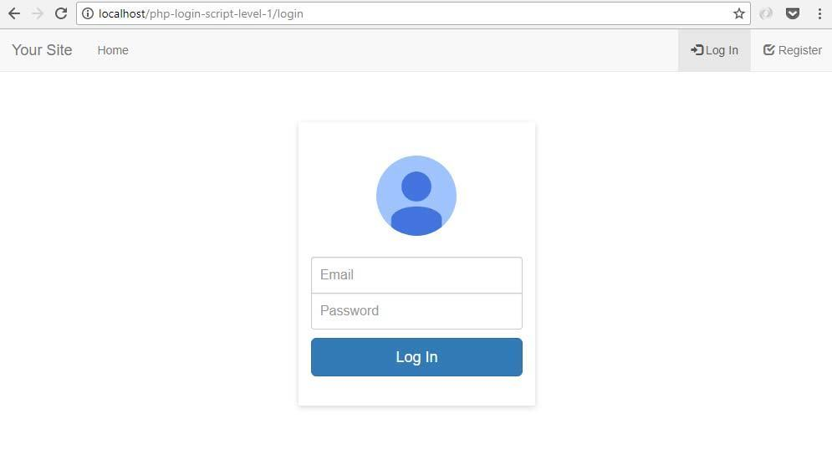
But our output does not work yet. Let's continue coding below.

7.4 Add alert message
These alert messages are shown based on the given action parameter. The system action was generated as a result of the activity the user has taken.
For example, the user tries to access a page where a login is required. The system will generate the "please_login" action that will be used to show a "Please login to access that page." message.
Replace "// alert messages will be here" of the previous section with the following code.
// get 'action' value in url parameter to display corresponding prompt messages
$action=isset($_GET['action']) ? $_GET['action'] : "";

// tell the user he is not yet logged in
if($action =='not_yet_logged_in'){
echo "<div class='alert alert-danger margin-top-40' role='alert'>Please login.</div>";
}

// tell the user to login
else if($action=='please_login'){
echo "<div class='alert alert-info'>
<strong>Please login to access that page.</strong>
</div>";
}

// tell the user email is verified
else if($action=='email_verified'){
echo "<div class='alert alert-success'>
<strong>Your email address have been validated.</strong>
</div>";
}

// tell the user if access denied
if($access_denied){
echo "<div class='alert alert-danger margin-top-40' role='alert'>
Access Denied.<br /><br />
Your username or password maybe incorrect
</div>";
}

7.5 Alert message output
Here's a sample output if we added the previous section's code. The alert message below were seen if the user tries to access the customer index page http://localhost/php-login-script-level-1/ without logging in.
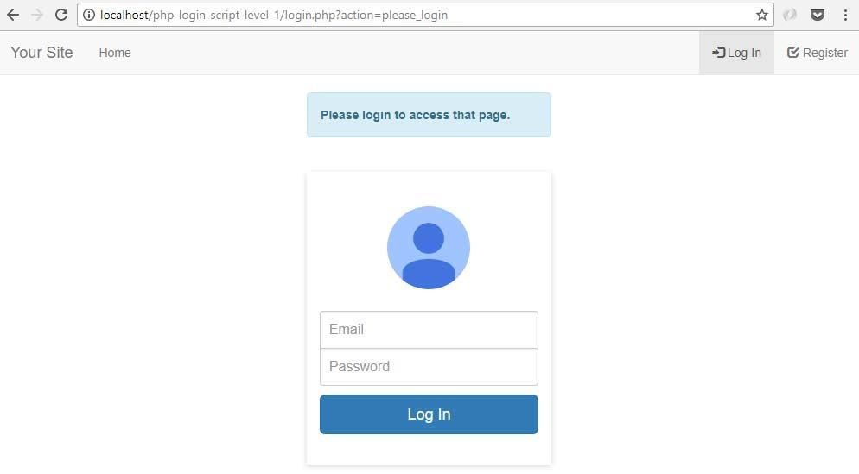

7.6 If user submitted the form
The following "if block" will execute a code when the user submitted the login form.
Find "// post code will be here" in "login.php" file. Replace it with the following code.
// if the login form was submitted
if($_POST){
// email check will be here
}

7.7 Check if email exists
The code below will check if the submitted email address exists in the database. The $user->emailExists(); function will return true or false.
Replace "// email check will be here" of the previous section with the following code.
// include classes
include_once "config/database.php";
include_once "objects/user.php";

// get database connection
$database = new Database();
$db = $database->getConnection();

// initialize objects
$user = new User($db);

// check if email and password are in the database
$user->email=$_POST['email'];

// check if email exists, also get user details using this emailExists() method
$email_exists = $user->emailExists();

// login validation will be here

7.8 Add emailExists() method
The previous section will not work without the following method inside the user class. This method will read a user record from the database based on a given email address.
Open "objects" folder. Open "user.php" file. Place the following method in user class.
// check if given email exist in the database
function emailExists(){

// query to check if email exists
$query = "SELECT id, firstname, lastname, access_level, password, status
FROM " . $this->table_name . "
WHERE email = ?
LIMIT 0,1";

// prepare the query
$stmt = $this->conn->prepare( $query );

// sanitize
$this->email=htmlspecialchars(strip_tags($this->email));

// bind given email value
$stmt->bindParam(1, $this->email);

// execute the query
$stmt->execute();

// get number of rows
$num = $stmt->rowCount();

// if email exists, assign values to object properties for easy access and use for php sessions
if($num>0){

// get record details / values
$row = $stmt->fetch(PDO::FETCH_ASSOC);

// assign values to object properties
$this->id = $row['id'];
$this->firstname = $row['firstname'];
$this->lastname = $row['lastname'];
$this->access_level = $row['access_level'];
$this->password = $row['password'];
$this->status = $row['status'];

// return true because email exists in the database
return true;
}

// return false if email does not exist in the database
return false;
}

7.9 Validate login credentials
The user will be allowed to login when $email_exists is true, the password matches and user status is equal to 1.
We used the built in PHP password_verify() function to match the submitted password with the hashed password in the database.
User status 1 means the user is verified. 0 means unverified. For this tutorial, we assume all users are verified.
Replace "// login validation will be here" of login.php with the following code.
// validate login
if ($email_exists && password_verify($_POST['password'], $user->password) && $user->status==1){

// if it is, set the session value to true
$_SESSION['logged_in'] = true;
$_SESSION['user_id'] = $user->id;
$_SESSION['access_level'] = $user->access_level;
$_SESSION['firstname'] = htmlspecialchars($user->firstname, ENT_QUOTES, 'UTF-8') ;
$_SESSION['lastname'] = $user->lastname;

// if access level is 'Admin', redirect to admin section
if($user->access_level=='Admin'){
header("Location: {$home_url}admin/index.php?action=login_success");
}

// else, redirect only to 'Customer' section
else{
header("Location: {$home_url}index.php?action=login_success");
}
}

// if username does not exist or password is wrong
else{
$access_denied=true;
}

7.10 Customer's index page
This file is shown when the user was successfully logged in.
Create "index.php" file. Place the following code.
<?php
// core configuration
include_once "config/core.php";

// set page title
$page_title="Index";

// include login checker
$require_login=true;
include_once "login_checker.php";

// include page header HTML
include_once 'layout_head.php';

echo "<div class='col-md-12'>";

// to prevent undefined index notice
$action = isset($_GET['action']) ? $_GET['action'] : "";

// if login was successful
if($action=='login_success'){
echo "<div class='alert alert-info'>";
echo "<strong>Hi " . $_SESSION['firstname'] . ", welcome back!</strong>";
echo "</div>";
}

// if user is already logged in, shown when user tries to access the login page
else if($action=='already_logged_in'){
echo "<div class='alert alert-info'>";
echo "<strong>You are already logged in.</strong>";
echo "</div>";
}

// content once logged in
echo "<div class='alert alert-info'>";
echo "Content when logged in will be here. For example, your premium products or services.";
echo "</div>";

echo "</div>";

// footer HTML and JavaScript codes
include 'layout_foot.php';
?>

7.11 Logout file
Here's how to logout the logged in user.
Create "logout.php" file. Place the following code.
<?php
// core configuration
include_once "config/core.php";

// destroy session, it will remove ALL session settings
session_destroy();

//redirect to login page
header("Location: {$home_url}login.php");
?>

7.12 Output
The login form and logout should work at this point. When you try to login a customer account. Use the following login credentials.
Username: darwin@example.com
Password: darwin12qw!@QW
Once logged-in, you will see the following.
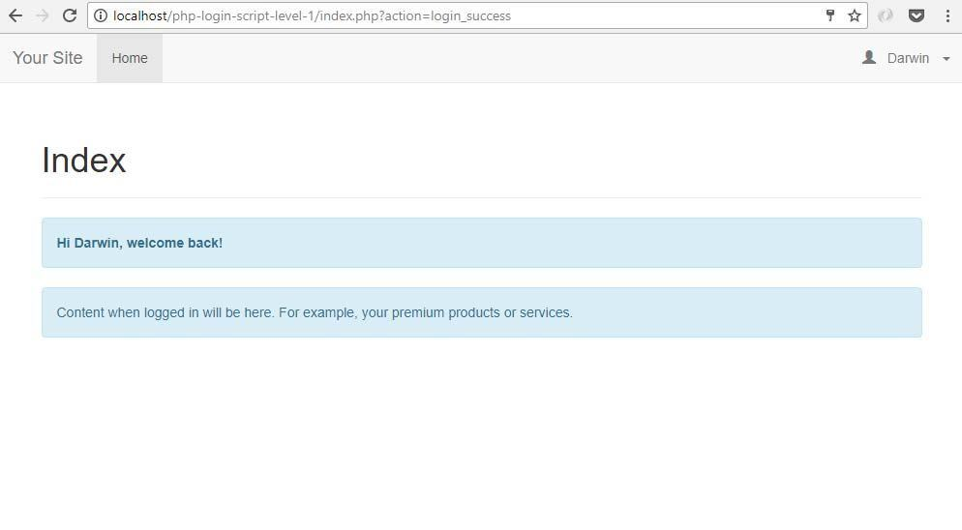

8.0 Create registration form

8.1 Create register page
The register page, also known as the "sign up" page, is where people will enter their information to be a registered user of the system.
Create "register.php" file. Place the following code.
<?php
// core configuration
include_once "config/core.php";

// set page title
$page_title = "Register";

// include login checker
include_once "login_checker.php";

// include classes
include_once 'config/database.php';
include_once 'objects/user.php';
include_once "libs/php/utils.php";

// include page header HTML
include_once "layout_head.php";

echo "<div class='col-md-12'>";

// registration form HTML will be here

echo "</div>";

// include page footer HTML
include_once "layout_foot.php";
?>

8.2 Create Utils class
This class is used for accessing common or general methods used by our application. This is a good practice. We will add this here so that it can be used later in this tutorial as well.
Open "libs" folder. Create "php" folder and open it. Create "utils.php" file. Place the following code.
<?php
class Utils{

}
?>

8.3 Registration form HTML
The register.php file does not have the registration form. We will place the registration form using the code below.
Replace "// registration form HTML will be here" of the previous section with the following code.
// code when form was submitted will be here
?>
<form action='register.php' method='post' id='register'>

<table class='table table-responsive'>

<tr>
<td class='width-30-percent'>Firstname</td>
<td><input type='text' name='firstname' class='form-control' required value="<?php echo isset($_POST['firstname']) ? htmlspecialchars($_POST['firstname'], ENT_QUOTES) : ""; ?>" /></td>
</tr>

<tr>
<td>Lastname</td>
<td><input type='text' name='lastname' class='form-control' required value="<?php echo isset($_POST['lastname']) ? htmlspecialchars($_POST['lastname'], ENT_QUOTES) : ""; ?>" /></td>
</tr>

<tr>
<td>Contact Number</td>
<td><input type='text' name='contact_number' class='form-control' required value="<?php echo isset($_POST['contact_number']) ? htmlspecialchars($_POST['contact_number'], ENT_QUOTES) : ""; ?>" /></td>
</tr>

<tr>
<td>Address</td>
<td><textarea name='address' class='form-control' required><?php echo isset($_POST['address']) ? htmlspecialchars($_POST['address'], ENT_QUOTES) : ""; ?></textarea></td>
</tr>

<tr>
<td>Email</td>
<td><input type='email' name='email' class='form-control' required value="<?php echo isset($_POST['email']) ? htmlspecialchars($_POST['email'], ENT_QUOTES) : ""; ?>" /></td>
</tr>

<tr>
<td>Password</td>
<td><input type='password' name='password' class='form-control' required id='passwordInput'></td>
</tr>

<tr>
<td></td>
<td>
<button type="submit" class="btn btn-primary">
<span class="glyphicon glyphicon-plus"></span> Register
</button>
</td>
</tr>

</table>
</form>
<?php

8.4 If registration form was submitted
This is code where the system will catch the information submitted by the user. The code below will try to detect if the registration form was submitted. It also validates if the submitted email already exists or not.
Replace "// code when form was submitted will be here" of the previous section with the following code.
// if form was posted
if($_POST){

// get database connection
$database = new Database();
$db = $database->getConnection();

// initialize objects
$user = new User($db);
$utils = new Utils();

// set user email to detect if it already exists
$user->email=$_POST['email'];

// check if email already exists
if($user->emailExists()){
echo "<div class='alert alert-danger'>";
echo "The email you specified is already registered. Please try again or <a href='{$home_url}login'>login.</a>";
echo "</div>";
}

else{
// create user will be here
}
}

8.5 Create new user
If the email does not exist, the program will create the user in the database. The code below will assign the submitted data to "user object" properties and then call the create() method.
Replace the comment "// create user will be here" of the previous section with the following code.
// set values to object properties
$user->firstname=$_POST['firstname'];
$user->lastname=$_POST['lastname'];
$user->contact_number=$_POST['contact_number'];
$user->address=$_POST['address'];
$user->password=$_POST['password'];
$user->access_level='Customer';
$user->status=1;

// create the user
if($user->create()){

echo "<div class='alert alert-info'>";
echo "Successfully registered. <a href='{$home_url}login'>Please login</a>.";
echo "</div>";

// empty posted values
$_POST=array();

}else{
echo "<div class='alert alert-danger' role='alert'>Unable to register. Please try again.</div>";
}

8.6 User object create() method
The create() method used in the previous section will not work without it in the user class. This method contains the INSERT query to the database, sanitizes the submitted data, binds the data and executes the query.
Open "objects" folder. Open "user.php" file. Add the following function inside the class.
// create new user record
function create(){

// to get time stamp for 'created' field
$this->created=date('Y-m-d H:i:s');

// insert query
$query = "INSERT INTO
" . $this->table_name . "
SET
firstname = :firstname,
lastname = :lastname,
email = :email,
contact_number = :contact_number,
address = :address,
password = :password,
access_level = :access_level,
status = :status,
created = :created";

// prepare the query
$stmt = $this->conn->prepare($query);

// sanitize
$this->firstname=htmlspecialchars(strip_tags($this->firstname));
$this->lastname=htmlspecialchars(strip_tags($this->lastname));
$this->email=htmlspecialchars(strip_tags($this->email));
$this->contact_number=htmlspecialchars(strip_tags($this->contact_number));
$this->address=htmlspecialchars(strip_tags($this->address));
$this->password=htmlspecialchars(strip_tags($this->password));
$this->access_level=htmlspecialchars(strip_tags($this->access_level));
$this->status=htmlspecialchars(strip_tags($this->status));

// bind the values
$stmt->bindParam(':firstname', $this->firstname);
$stmt->bindParam(':lastname', $this->lastname);
$stmt->bindParam(':email', $this->email);
$stmt->bindParam(':contact_number', $this->contact_number);
$stmt->bindParam(':address', $this->address);

// hash the password before saving to database
$password_hash = password_hash($this->password, PASSWORD_BCRYPT);
$stmt->bindParam(':password', $password_hash);

$stmt->bindParam(':access_level', $this->access_level);
$stmt->bindParam(':status', $this->status);
$stmt->bindParam(':created', $this->created);

// execute the query, also check if query was successful
if($stmt->execute()){
return true;
}else{
$this->showError($stmt);
return false;
}

}

8.7 Add showError() method
The purpose of this method is to show additional details about an error.
public function showError($stmt){
echo "<pre>";
print_r($stmt->errorInfo());
echo "</pre>";
}

8.8 Output
Run http://localhost/php-login-script-level-1/register, you should see an output the looks like the screenshot below. It will display appropriate alert message when the registration form was submitted.
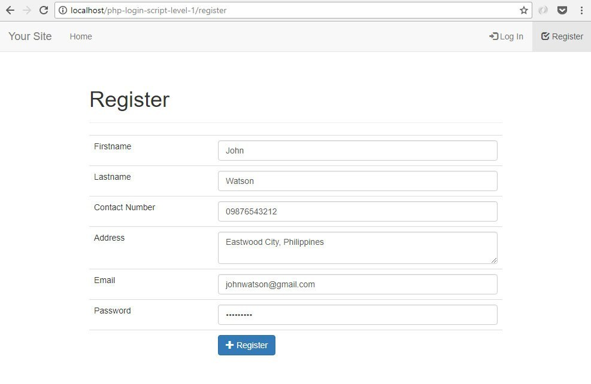

9.0 Admin section

9.1 Create admin index page
Once the an admin user successfully logged in, this admin index page is where he will land.
Create "admin" folder. Create "index.php" file. Place the following code.
<?php
// core configuration
include_once "../config/core.php";

// check if logged in as admin
include_once "login_checker.php";

// set page title
$page_title="Admin Index";

// include page header HTML
include 'layout_head.php';

echo "<div class='col-md-12'>";

// get parameter values, and to prevent undefined index notice
$action = isset($_GET['action']) ? $_GET['action'] : "";

// tell the user he's already logged in
if($action=='already_logged_in'){
echo "<div class='alert alert-info'>";
echo "<strong>You</strong> are already logged in.";
echo "</div>";
}

else if($action=='logged_in_as_admin'){
echo "<div class='alert alert-info'>";
echo "<strong>You</strong> are logged in as admin.";
echo "</div>";
}

echo "<div class='alert alert-info'>";
echo "Contents of your admin section will be here.";
echo "</div>";

echo "</div>";

// include page footer HTML
include_once 'layout_foot.php';
?>

9.2 Create navigation bar
The admin section has its own navigation bar. The reason is the admin menu can be very different from the user menu.
Open "admin" folder. Create "navigation.php" file. Place the following code.
<!-- navbar -->
<div class="navbar navbar-default navbar-static-top" role="navigation">
<div class="container-fluid">

<div class="navbar-header">
<!-- to enable navigation dropdown when viewed in mobile device -->
<button type="button" class="navbar-toggle" data-toggle="collapse" data-target=".navbar-collapse">
<span class="sr-only">Toggle navigation</span>
<span class="icon-bar"></span>
<span class="icon-bar"></span>
<span class="icon-bar"></span>
</button>

<!-- Change "Site Admin" to your site name -->
<a class="navbar-brand" href="<?php echo $home_url; ?>admin/index.php">Admin</a>
</div>

<div class="navbar-collapse collapse">
<ul class="nav navbar-nav">

<!-- highlight for order related pages -->
<li <?php echo $page_title=="Admin Index" ? "class='active'" : ""; ?>>
<a href="<?php echo $home_url; ?>admin/index.php">Home</a>
</li>

<!-- highlight for user related pages -->
<li <?php
echo $page_title=="Users" ? "class='active'" : ""; ?> >
<a href="<?php echo $home_url; ?>admin/read_users.php">Users</a>
</li>
</ul>

<!-- options in the upper right corner of the page -->
<ul class="nav navbar-nav navbar-right">
<li>
<a href="#" class="dropdown-toggle" data-toggle="dropdown" role="button" aria-expanded="false">
<span class="glyphicon glyphicon-user" aria-hidden="true"></span>
&nbsp;&nbsp;<?php echo $_SESSION['firstname']; ?>
&nbsp;&nbsp;<span class="caret"></span>
</a>
<ul class="dropdown-menu" role="menu">
<!-- log out user -->
<li><a href="<?php echo $home_url; ?>logout.php">Logout</a></li>
</ul>
</li>
</ul>

</div><!--/.nav-collapse -->

</div>
</div>
<!-- /navbar -->

9.3 Create page header
This page header file is for admin section only. This is where the navigation bar of the previous section was used.
Open "admin" folder. Create "layout_head.php" file. Place the following code.
<!DOCTYPE html>
<html lang="en">
<head>

<meta charset="utf-8">
<meta http-equiv="X-UA-Compatible" content="IE=edge">
<meta name="viewport" content="width=device-width, initial-scale=1">

<title><?php echo isset($page_title) ? strip_tags($page_title) : "Store Admin"; ?></title>

<!-- Bootstrap CSS -->
<link href="https://maxcdn.bootstrapcdn.com/bootstrap/3.3.7/css/bootstrap.min.css" rel="stylesheet" media="screen" />

<!-- admin custom CSS -->
<link href="<?php echo $home_url . "libs/css/admin.css" ?>" rel="stylesheet" />

</head>
<body>

<?php
// include top navigation bar
include_once "navigation.php";
?>

<!-- container -->
<div class="container">

<!-- display page title -->
<div class="col-md-12">
<div class="page-header">
<h1><?php echo isset($page_title) ? $page_title : "The Code of a Ninja"; ?></h1>
</div>
</div>

9.4 Create page footer
This page footer file is for admin section only as well.
Open "admin" folder. Create "layout_foot.php" file. Place the following code.
</div>
<!-- /container -->

<!-- jQuery library -->
<script src="https://code.jquery.com/jquery-3.2.1.min.js"></script>

<!-- Bootstrap JavaScript -->
<script src="https://maxcdn.bootstrapcdn.com/bootstrap/3.3.7/js/bootstrap.min.js"></script>

<!-- end the HTML page -->
</body>
</html>

9.5 Admin section custom CSS
There are differences in style in the admin section as well. For this reason, we need a different custom.css file.
Open "libs" folder. Open "css" folder. Create "admin.css" file. Place the following code.
.right-button-margin{
margin: 0 0 1em 0;
overflow: hidden;
}

.thumb-image {
float:left;
width: 150px;
height: 150px;
margin:.6em 1.2em 0 0;
position:relative;
}

.thumb-image .delete-image {
position:absolute;
top:-10px;
right:-10px;
}

.thumb-wrapper{
border:thin solid #999;
float:left;
width: 150px;
height: 150px;
margin:.6em 1.2em 0 0;
position:relative;
}

.width-30-percent{ width:30%; }
.margin-left-1em{ margin:0 1em 0 0; }
.width-20-em{ width: 20em; }
.width-13-em{ width: 13em; }
.margin-zero{ margin:0; }
.padding-zero{ padding:0; }
.btn-margin-right{ margin-right:.5em; }
.margin-bottom-1em{ margin-bottom:1em; }
.left-margin{ margin:0 .5em 0 0; }
.delete-image img{ width:25px; }
.thumb-wrapper img{ width:130px; height:130px; margin:10px; }
#html-btn { display:none; }
.delete-pdf{ margin-left:.5em; }
.delete-pdf img{ width:20px; cursor:pointer; }
.pdf-item{ padding:0 0 1em 0; }

9.6 Create login checker file
We choose to use a different login checker for the admin section. This is because there can be different redirects required by the admin section.
Open "admin" folder. Create "login_checker.php" file. Place the following code.
<?php
// login checker for 'admin' access level

// if the session value is empty, he is not yet logged in, redirect him to login page
if(empty($_SESSION['logged_in'])){
header("Location: {$home_url}login.php?action=not_yet_logged_in");
}

// if access level was not 'Admin', redirect him to login page
else if($_SESSION['access_level']!="Admin"){
header("Location: {$home_url}login.php?action=not_admin");
}

else{
// no problem, stay on current page
}
?>

9.7 Output
Use the following login credentials to login an admin account.
Username: mike@example.com
Password: ninja12qw!@QW
Once logged-in, you will see the following.
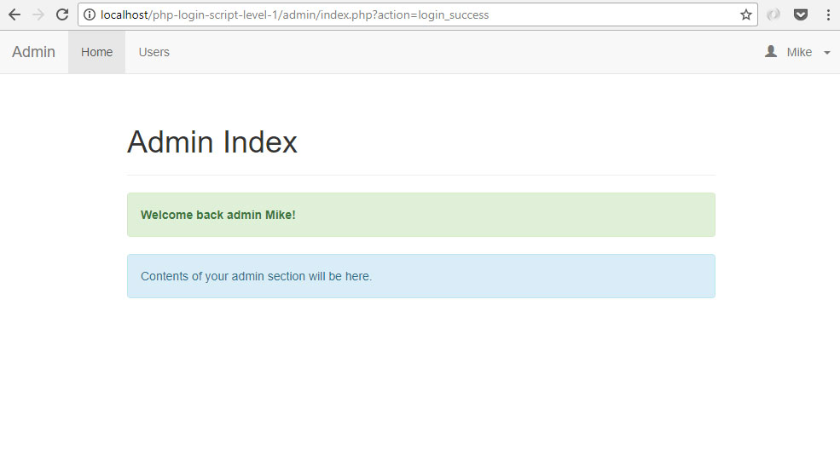

10.0 Show registered users

10.1 Create "read users" file
This file will is what was accessed in the browser to show the list of registered users.
Create read_users.php file. Place the following code.
<?php
// core configuration
include_once "../config/core.php";

// check if logged in as admin
include_once "login_checker.php";

// include classes
include_once '../config/database.php';
include_once '../objects/user.php';

// get database connection
$database = new Database();
$db = $database->getConnection();

// initialize objects
$user = new User($db);

// set page title
$page_title = "Users";

// include page header HTML
include_once "layout_head.php";

echo "<div class='col-md-12'>";

// read all users from the database
$stmt = $user->readAll($from_record_num, $records_per_page);

// count retrieved users
$num = $stmt->rowCount();

// to identify page for paging
$page_url="read_users.php?";

// include products table HTML template
include_once "read_users_template.php";

echo "</div>";

// include page footer HTML
include_once "layout_foot.php";
?>

10.2 Add readAll() method in user object
This method is needed by the previous section to retrieved records from the database.
Open "objects" folder. Open "user.php" file. Place the following code inside the class.
// read all user records
function readAll($from_record_num, $records_per_page){

// query to read all user records, with limit clause for pagination
$query = "SELECT
id,
firstname,
lastname,
email,
contact_number,
access_level,
created
FROM " . $this->table_name . "
ORDER BY id DESC
LIMIT ?, ?";

// prepare query statement
$stmt = $this->conn->prepare( $query );

// bind limit clause variables
$stmt->bindParam(1, $from_record_num, PDO::PARAM_INT);
$stmt->bindParam(2, $records_per_page, PDO::PARAM_INT);

// execute query
$stmt->execute();

// return values
return $stmt;
}

10.3 Create "read users" template file
The HTML table is where the records are placed. We used a template file so that we can use the same layout for the search feature.
Create read_users_template.php file. Place the following code.
<?php
// display the table if the number of users retrieved was greater than zero
if($num>0){

echo "<table class='table table-hover table-responsive table-bordered'>";

// table headers
echo "<tr>";
echo "<th>Firstname</th>";
echo "<th>Lastname</th>";
echo "<th>Email</th>";
echo "<th>Contact Number</th>";
echo "<th>Access Level</th>";
echo "</tr>";

// loop through the user records
while ($row = $stmt->fetch(PDO::FETCH_ASSOC)){
extract($row);

// display user details
echo "<tr>";
echo "<td>{$firstname}</td>";
echo "<td>{$lastname}</td>";
echo "<td>{$email}</td>";
echo "<td>{$contact_number}</td>";
echo "<td>{$access_level}</td>";
echo "</tr>";
}

echo "</table>";

$page_url="read_users.php?";
$total_rows = $user->countAll();

// actual paging buttons
include_once 'paging.php';
}

// tell the user there are no selfies
else{
echo "<div class='alert alert-danger'>
<strong>No users found.</strong>
</div>";
}
?>

10.4 Add countAll() method in user object
The data returned by the countAll() method is used for calculating the correct pagination buttons.
Open "objects" folder. Open "user.php" file. Place the following code inside the class.
// used for paging users
public function countAll(){

// query to select all user records
$query = "SELECT id FROM " . $this->table_name . "";

// prepare query statement
$stmt = $this->conn->prepare($query);

// execute query
$stmt->execute();

// get number of rows
$num = $stmt->rowCount();

// return row count
return $num;
}

PAREI

10.5 Paginate list of users
This pagination file renders the clickable page buttons. It can be used for different objects as well, not just users.
Create paging.php file. Place the following code.
<?php
echo "<ul class=\"pagination margin-zero\">";

// button for first page
if($page>1){
echo "<li><a href='{$page_url}' title='Go to the first page.'>";
echo "First Page";
echo "</a></li>";
}

// calculate total number of pages
$total_pages = ceil($total_rows / $records_per_page);

// range of links to show
$range = 2;

// display links to 'range of pages' around 'current page'
$initial_num = $page - $range;
$condition_limit_num = ($page + $range) + 1;

for ($x=$initial_num; $x<$condition_limit_num; $x++) {

// be sure '$x is greater than 0' AND 'less than or equal to the $total_pages'
if (($x > 0) && ($x <= $total_pages)) {

// current page
if ($x == $page) {
echo "<li class='active'><a href=\"#\">$x <span class=\"sr-only\">(current)</span></a></li>";
}

// not current page
else {
echo "<li><a href='{$page_url}page=$x'>$x</a></li>";
}
}
}

// button for last page
if($page<$total_pages){
echo "<li><a href='" .$page_url . "page={$total_pages}' title='Last page is {$total_pages}.'>";
echo "Last Page";
echo "</a></li>";
}

echo "</ul>";
?>

10.6 Output
Login as admin and go to http://localhost/php-login-script-level-1/admin/read_users.php, you should see an output like the following.
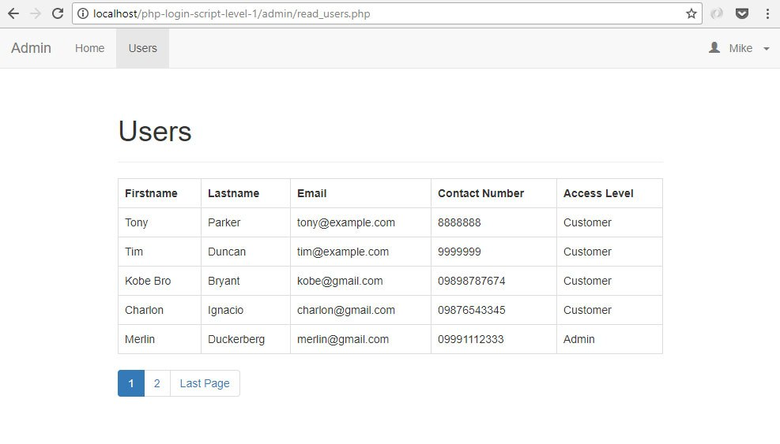

11.0 How to validate email address?
This is a bonus section. This feature is not part of LEVEL 1 source code.
This feature needs a remote server where PHP mail function works. It does not work in localhost.

11.1 Change account status
If the user status is equal to 1, it means the email account is valid.
Since we want the user to validate his own email address, we will make it invalid (status equals to 0) the first time he register an account to our system.
Open register.php file and find:
$user->status=1;

Change the it to:
$user->status=0;

11.2 Add access code field
Access code is a unique string of characters that is needed for email validation process. Still in register.php, place the following code under the code of the previous section.
// access code for email verification
$access_code=$utils->getToken();
$user->access_code=$access_code;

11.3 Add getToken() method
This method will generate a unique string of characters for the access code field of the previous section.
Open "libs/php/utils.php" file and place the following code inside the class.
function getToken($length=32){
$token = "";
$codeAlphabet = "ABCDEFGHIJKLMNOPQRSTUVWXYZ";
$codeAlphabet.= "abcdefghijklmnopqrstuvwxyz";
$codeAlphabet.= "0123456789";
for($i=0;$i<$length;$i++){
$token .= $codeAlphabet[$this->crypto_rand_secure(0,strlen($codeAlphabet))];
}
return $token;
}

function crypto_rand_secure($min, $max) {
$range = $max - $min;
if ($range < 0) return $min; // not so random...
$log = log($range, 2);
$bytes = (int) ($log / 8) + 1; // length in bytes
$bits = (int) $log + 1; // length in bits
$filter = (int) (1 << $bits) - 1; // set all lower bits to 1
do {
$rnd = hexdec(bin2hex(openssl_random_pseudo_bytes($bytes)));
$rnd = $rnd & $filter; // discard irrelevant bits
} while ($rnd >= $range);
return $min + $rnd;
}

11.4 Change create() method
Since we added a new field, we need to change the create() method in the User class.
Open objects/user.php file. Replace the create() method with the new one below.
// create new user record
function create(){

// to get time stamp for 'created' field
$this->created=date('Y-m-d H:i:s');

// insert query
$query = "INSERT INTO " . $this->table_name . "
SET
firstname = :firstname,
lastname = :lastname,
email = :email,
contact_number = :contact_number,
address = :address,
password = :password,
access_level = :access_level,
access_code = :access_code,
status = :status,
created = :created";

// prepare the query
$stmt = $this->conn->prepare($query);

// sanitize
$this->firstname=htmlspecialchars(strip_tags($this->firstname));
$this->lastname=htmlspecialchars(strip_tags($this->lastname));
$this->email=htmlspecialchars(strip_tags($this->email));
$this->contact_number=htmlspecialchars(strip_tags($this->contact_number));
$this->address=htmlspecialchars(strip_tags($this->address));
$this->password=htmlspecialchars(strip_tags($this->password));
$this->access_level=htmlspecialchars(strip_tags($this->access_level));
$this->access_code=htmlspecialchars(strip_tags($this->access_code));
$this->status=htmlspecialchars(strip_tags($this->status));

// bind the values
$stmt->bindParam(':firstname', $this->firstname);
$stmt->bindParam(':lastname', $this->lastname);
$stmt->bindParam(':email', $this->email);
$stmt->bindParam(':contact_number', $this->contact_number);
$stmt->bindParam(':address', $this->address);

// hash the password before saving to database
$password_hash = password_hash($this->password, PASSWORD_BCRYPT);
$stmt->bindParam(':password', $password_hash);

$stmt->bindParam(':access_level', $this->access_level);
$stmt->bindParam(':access_code', $this->access_code);
$stmt->bindParam(':status', $this->status);
$stmt->bindParam(':created', $this->created);

// execute the query, also check if query was successful
if($stmt->execute()){
return true;
}else{
$this->showError($stmt);
return false;
}

}

11.5 Add access_code property
The previous section will not work without this new "access_code" property. Open on objects/user.php file, find this line:
public $access_level;

And add the following code under it.
public $access_code;

11.6 Send verification email
Instead of just displaying "Successfully registered." message, we will send a verification link to user's email address.
This means we will use a new function and message saying "Verification link was sent to your email. Click that link to login.".
Open register.php file and find the following "if-else" statement.
// create the user
if($user->create()){

echo "<div class='alert alert-info'>";
echo "Successfully registered. <a href='{$home_url}login'>Please login</a>.";
echo "</div>";

// empty posted values
$_POST=array();

}else{
echo "<div class='alert alert-danger' role='alert'>Unable to register. Please try again.</div>";
}

Replace it with the following code.
// create the user
if($user->create()){

// send confimation email
$send_to_email=$_POST['email'];
$body="Hi {$send_to_email}.<br /><br />";
$body.="Please click the following link to verify your email and login: {$home_url}verify/?access_code={$access_code}";
$subject="Verification Email";

if($utils->sendEmailViaPhpMail($send_to_email, $subject, $body)){
echo "<div class='alert alert-success'>
Verification link was sent to your email. Click that link to login.
</div>";
}

else{
echo "<div class='alert alert-danger'>
User was created but unable to send verification email. Please contact admin.
</div>";
}

// empty posted values
$_POST=array();

}else{
echo "<div class='alert alert-danger' role='alert'>Unable to register. Please try again.</div>";
}

11.7 Add sendEmailViaPhpMail() method
This method will help send the email with verification link to the email address submitted by the user. It uses the built-in PHP mail() function.
Open "libs/php/utils.php" file. Place the following code inside the class.
// send email using built in php mailer
public function sendEmailViaPhpMail($send_to_email, $subject, $body){

$from_name="Your Name";
$from_email="yourname@yourdomain.com";

$headers = "MIME-Version: 1.0\r\n";
$headers .= "Content-type: text/html; charset=iso-8859-1\r\n";
$headers .= "From: {$from_name} <{$from_email}> \n";

if(mail($send_to_email, $subject, $body, $headers)){
return true;
}

return false;
}

Change the $from_name and $from_email variable values to your own.

11.8 Output
Try to register a new account. After submitting the form, you will see a message box like the following. Follow what the message says to validate the email address.
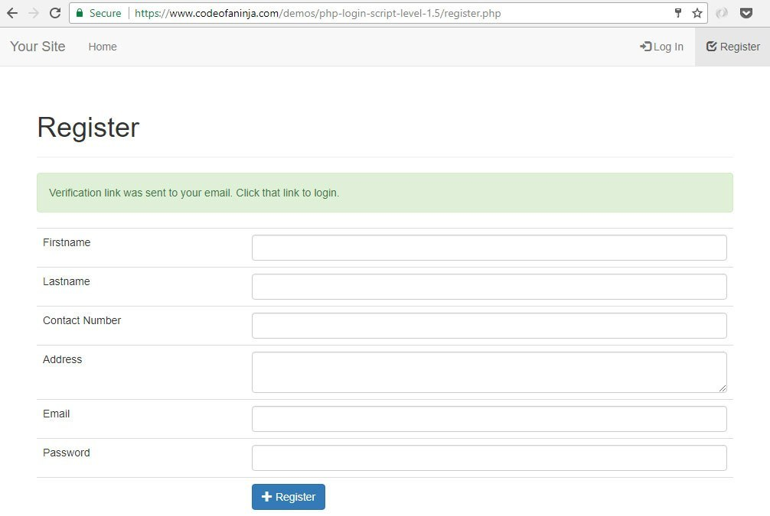
The verification email that the user will receive looks like the following. You can always change the copy of this message using the $subject and $body variables.
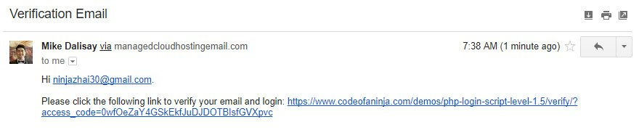

11.9 Create verification file
Once the user clicked the verification link, the system will change the status from 0 to 1.
He will be redirected to the login page with a confirmation message as well.
Create verify.php file in your project's main directory. Place the following code.
<?php
// core configuration
include_once "config/core.php";

// include classes
include_once 'config/database.php';
include_once 'objects/user.php';

// get database connection
$database = new Database();
$db = $database->getConnection();

// initialize objects
$user = new User($db);

// set access code
$user->access_code=isset($_GET['access_code']) ? $_GET['access_code'] : "";

// verify if access code exists
if(!$user->accessCodeExists()){
die("ERROR: Access code not found.");
}

// redirect to login
else{

// update status
$user->status=1;
$user->updateStatusByAccessCode();

// and the redirect
header("Location: {$home_url}login.php?action=email_verified");
}
?>

11.10 Add accessCodeExists() method
This method will check the database if an access code already exists. It will return true if it found something, else, it will return false.
Open “objects/user.php” file. Add the following code inside the class.
// check if given access_code exist in the database
function accessCodeExists(){

// query to check if access_code exists
$query = "SELECT id
FROM " . $this->table_name . "
WHERE access_code = ?
LIMIT 0,1";

// prepare the query
$stmt = $this->conn->prepare( $query );

// sanitize
$this->access_code=htmlspecialchars(strip_tags($this->access_code));

// bind given access_code value
$stmt->bindParam(1, $this->access_code);

// execute the query
$stmt->execute();

// get number of rows
$num = $stmt->rowCount();

// if access_code exists
if($num>0){

// return true because access_code exists in the database
return true;
}

// return false if access_code does not exist in the database
return false;

}

11.11 Add updateStatusByAccessCode() method
Open "objects" folder. Open "user.php" file. Add the following method inside the class.
// used in email verification feature
function updateStatusByAccessCode(){

// update query
$query = "UPDATE " . $this->table_name . "
SET status = :status
WHERE access_code = :access_code";

// prepare the query
$stmt = $this->conn->prepare($query);

// sanitize
$this->status=htmlspecialchars(strip_tags($this->status));
$this->access_code=htmlspecialchars(strip_tags($this->access_code));

// bind the values from the form
$stmt->bindParam(':status', $this->status);
$stmt->bindParam(':access_code', $this->access_code);

// execute the query
if($stmt->execute()){
return true;
}

return false;
}

11.12 Output
The previous code will redirect the user to the following page.
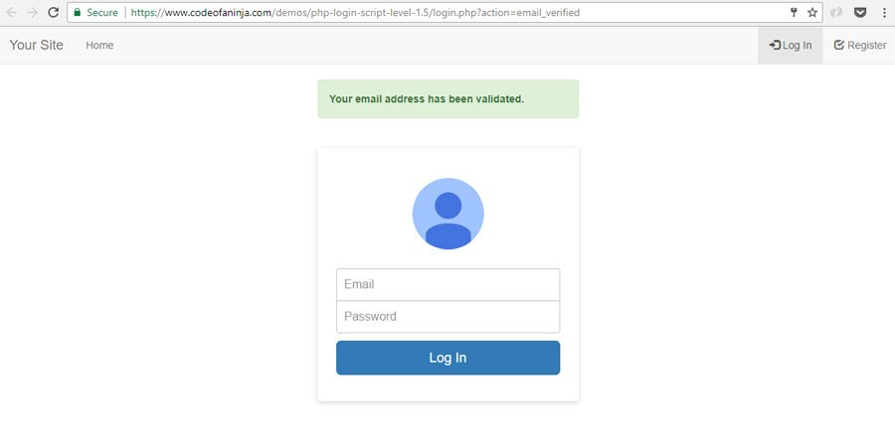

12.0 PHP forgot password
This is a bonus section. This feature is not part of LEVEL 1 source code.
This feature needs a remote server where PHP mail() function works. It does not work in localhost.

12.1 Add forgot password link
Open login.php file and find the login button. Look for a line that looks like the following code.
echo "<input type='submit' class='btn btn-lg btn-primary btn-block' value='Log In' />";

Once you found it, place the following code under it.
echo "<div class='margin-1em-zero text-align-center'>
<a href='{$home_url}forgot_password'>Forgot password?</a>
</div>";

12.2 Login page new output
The login page will have the "Forgot password?" link after doing the code in the previous section.
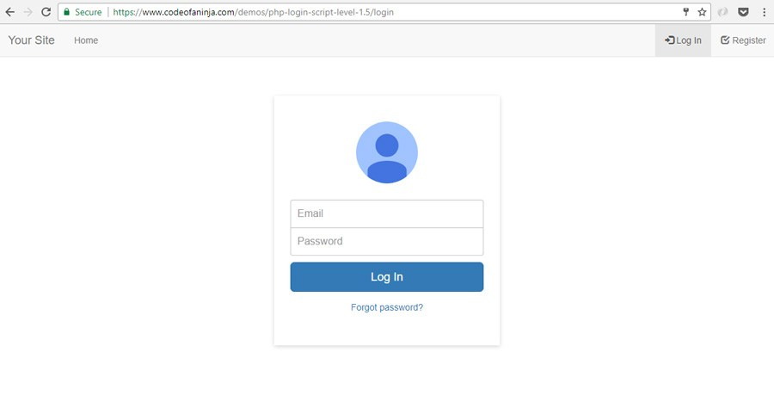

12.3 Create "forgot password" page
This is the page where the user lands when he clicked the "Forgot password?" link on the login page.
Create forgot_password.php file in your project's main directory. Place the following code.
<?php
// core configuration
include_once "config/core.php";

// set page title
$page_title = "Forgot Password";

// include login checker
include_once "login_checker.php";

// include classes
include_once "config/database.php";
include_once 'objects/user.php';
include_once "libs/php/utils.php";

// get database connection
$database = new Database();
$db = $database->getConnection();

// initialize objects
$user = new User($db);
$utils = new Utils();

// include page header HTML
include_once "layout_head.php";

// post code will be here

// show reset password HTML form
echo "<div class='col-md-4'></div>";
echo "<div class='col-md-4'>";

echo "<div class='account-wall'>
<div id='my-tab-content' class='tab-content'>
<div class='tab-pane active' id='login'>
<img class='profile-img' src='images/login-icon.png'>
<form class='form-signin' action='" . htmlspecialchars($_SERVER["PHP_SELF"]) . "' method='post'>
<input type='email' name='email' class='form-control' placeholder='Your email' required autofocus>
<input type='submit' class='btn btn-lg btn-primary btn-block' value='Send Reset Link' style='margin-top:1em;' />
</form>
</div>
</div>
</div>";

echo "</div>";
echo "<div class='col-md-4'></div>";

// footer HTML and JavaScript codes
include_once "layout_foot.php";
?>

12.4 Forgot password page output
After doing the code above, run forget_password.php on your browser. You will see the following output.
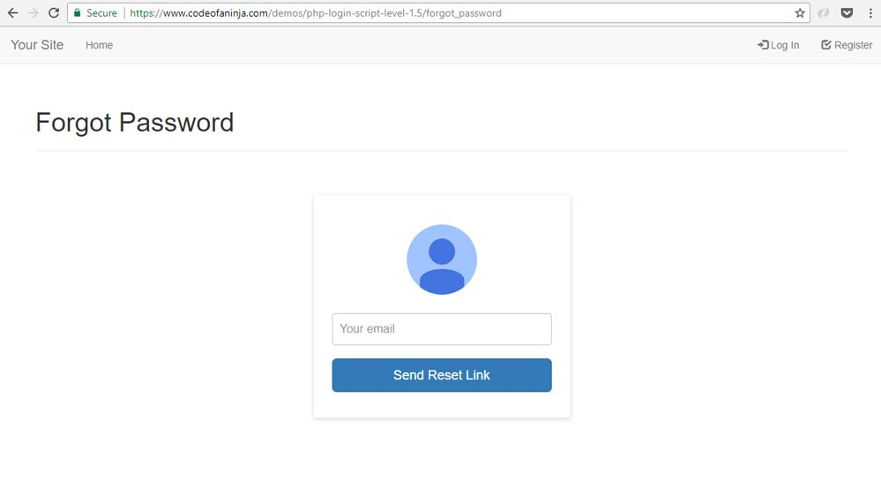

12.5 Add post code
Once the user entered his email address and submitted the form, this code will be executed.
Replace "// post code will be here" with the following code.
// if the login form was submitted
if($_POST){

echo "<div class='col-sm-12'>";

// check if username and password are in the database
$user->email=$_POST['email'];

if($user->emailExists()){

// update access code for user
$access_code=$utils->getToken();

$user->access_code=$access_code;
if($user->updateAccessCode()){

// send reset link
$body="Hi there.<br /><br />";
$body.="Please click the following link to reset your password: {$home_url}reset_password/?access_code={$access_code}";
$subject="Reset Password";
$send_to_email=$_POST['email'];

if($utils->sendEmailViaPhpMail($send_to_email, $subject, $body)){
echo "<div class='alert alert-info'>
Password reset link was sent to your email.
Click that link to reset your password.
</div>";
}

// message if unable to send email for password reset link
else{ echo "<div class='alert alert-danger'>ERROR: Unable to send reset link.</div>"; }
}

// message if unable to update access code
else{ echo "<div class='alert alert-danger'>ERROR: Unable to update access code.</div>"; }

}

// message if email does not exist
else{ echo "<div class='alert alert-danger'>Your email cannot be found.</div>"; }

echo "</div>";
}

12.6 Add updateAccessCode() method
Open "objects" folder. Open "user.php" file. Add the following method inside the class.
// used in forgot password feature
function updateAccessCode(){

// update query
$query = "UPDATE
" . $this->table_name . "
SET
access_code = :access_code
WHERE
email = :email";

// prepare the query
$stmt = $this->conn->prepare($query);

// sanitize
$this->access_code=htmlspecialchars(strip_tags($this->access_code));
$this->email=htmlspecialchars(strip_tags($this->email));

// bind the values from the form
$stmt->bindParam(':access_code', $this->access_code);
$stmt->bindParam(':email', $this->email);

// execute the query
if($stmt->execute()){
return true;
}

return false;
}

12.7 Output
Here's a sample email sent after the user submitted his email address in using the "forgot password" form.
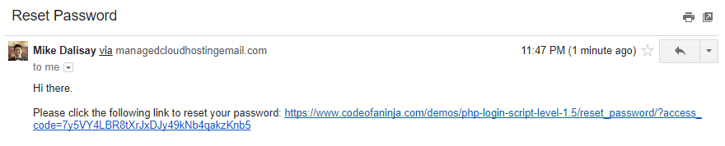

13.0 PHP reset password form
The "reset password" form is shown when the user clicked the link sent by the system after the "forgot password" request.

13.1 Create "reset password" page
If the use clicks the link on the email our system sent, he will land to this page where he will change his password.
Create reset_password.php file. Place the following code.
<?php
// core configuration
include_once "config/core.php";

// set page title
$page_title = "Reset Password";

// include login checker
include_once "login_checker.php";

// include classes
include_once "config/database.php";
include_once "objects/user.php";

// get database connection
$database = new Database();
$db = $database->getConnection();

// initialize objects
$user = new User($db);

// include page header HTML
include_once "layout_head.php";

echo "<div class='col-sm-12'>";

// check acess code will be here

echo "</div>";

// include page footer HTML
include_once "layout_foot.php";
?>

13.2 Check access code
We need to check the access code to verify if the request came from the email generated by our system.
Replace the comment "// check acess code will be here" of the previous section with the following code.
// get given access code
$access_code=isset($_GET['access_code']) ? $_GET['access_code'] : die("Access code not found.");

// check if access code exists
$user->access_code=$access_code;

if(!$user->accessCodeExists()){
die('Access code not found.');
}

else{
// reset password form will be here
}

13.3 Add "reset password" form
If the access code exists, the page will render a form where the user can enter his new password.
Once the user submitted a new password, the database will be updated with this new password data.
Replace the comment "// reset password form will be here" of the previous section with the following code.
// post code will be here

echo "<form action='" . htmlspecialchars($_SERVER["PHP_SELF"]) . "?access_code={$access_code}' method='post'>
<table class='table table-hover table-responsive table-bordered'>
<tr>
<td>Password</td>
<td><input type='password' name='password' class='form-control' required></td>
</tr>
<tr>
<td></td>
<td><button type='submit' class='btn btn-primary'>Reset Password</button></td>
</tr>
</table>
</form>";

13.4 Add post code
Replace the comment "// post code will be here" of the previous section with the following code.
// if form was posted
if($_POST){

// set values to object properties
$user->password=$_POST['password'];

// reset password
if($user->updatePassword()){
echo "<div class='alert alert-info'>Password was reset. Please <a href='{$home_url}login'>login.</a></div>";
}

else{
echo "<div class='alert alert-danger'>Unable to reset password.</div>";
}
}

13.5 Add updatePassword() method
This method will help update the password in the database. The previous section won't work without this method in the User class.
Open "objects/user.php" file. Add the following code inside the class.
// used in forgot password feature
function updatePassword(){

// update query
$query = "UPDATE " . $this->table_name . "
SET password = :password
WHERE access_code = :access_code";

// prepare the query
$stmt = $this->conn->prepare($query);

// sanitize
$this->password=htmlspecialchars(strip_tags($this->password));
$this->access_code=htmlspecialchars(strip_tags($this->access_code));

// bind the values from the form
$password_hash = password_hash($this->password, PASSWORD_BCRYPT);
$stmt->bindParam(':password', $password_hash);
$stmt->bindParam(':access_code', $this->access_code);

// execute the query
if($stmt->execute()){
return true;
}

return false;
}

13.6 Output
To run reset_password.php file, click the link sent to your email address via "forgot password" form.
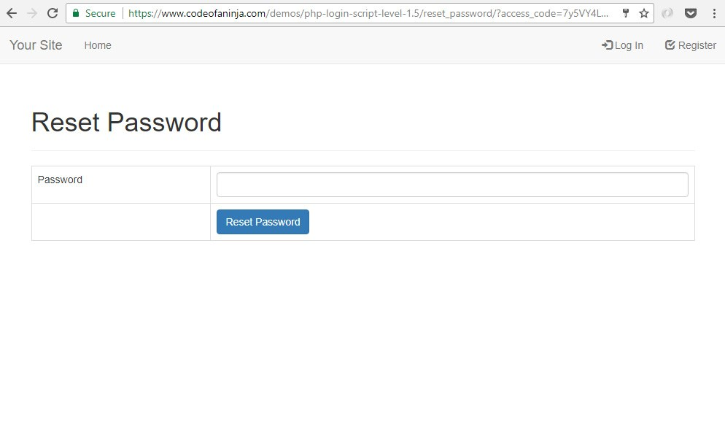

14.0 How To Run The Source Code?
We highly recommend for you to follow and study our well-detailed, step-by-step tutorial above first. Nothing beats experience when it comes to learning.
But we believe you will learn faster if you’ll see the final source code as well. We consider it as your additional guide.
Imagine the value or skill upgrade it can bring you. The additional income you can get from your work, projects or business. The precious time you save. Isn’t that what you want?
By now, you need to download our source codes. To do it, use any download buttons in the next few sections below.
Once you downloaded the source codes, here’s how you can run it.
I assume you work in localhost with your XAMPP server running. If not, learn from our tutorial here.
- Extract the ZIP file in your htdocs directory. You should have "php-login-script-level-1" folder with the files there.
- In your PhpMyAdmin, create a database "php_login_system"
- Import the "php_login_system.sql" file in the "README" folder
- If needed, configure database in /config/database.php
- If needed, configure $home_url in /config/core.php
- If needed, change rewrite base directory in line 7 of .htaccess file
- Open a new browser tab, paste this URL http://localhost/php-login-script-level-1/login and see the magic.
Try to login using the following credentials.
Admin Section Login
Username: mike@example.com
Password: ninja12qw!@QW
Customer Account Login
Username: darwin@example.com
Password: darwin12qw!@QW
Other notes:
- This system works with PHP 5.5 or greater.
- Rewrite module is usually enabled by default. If not, it must be enable in your apache server.

